**TIPS FOR KEEPING YOURSELF SAFE**

**Bullying**  **–** If you think a pupil or adult is bullying you or someone you know, you must tell you parents/carers, a teacher or trusted adult.

**Saying unkind things to you** – If a student or adult says something to you, or you hear something that you do not like or that upsets you, you must tell your parents/carers, a teacher or trusted adult.

**Touching you** – Your body belongs to you and not to anyone else. This means all your body. If someone touches you and you do not like it, it is not ok. You must tell your parents/carers, a teacher or trusted adult.

**Hitting, punching, or smacking you** – if a pupil or adult hits you, punches or smacks you or hurts you in any way, you must tell your parents/carers, a teacher or trusted adult.

**Secrets** – Secrets, such as surprise parties are fun, but some secrets are not good and should never be kept.

**Presents** – Presents are a good thing to get, but you should not take a present from anyone without checking with your parents/carers first. Most of the time it will be ok, but sometimes people try and trick children into doing something by giving them presents (like sweets, money, phones, cigarettes or drugs and alcohol). This is sometimes called a bribe. If it does not seem right, tell someone as soon as you can.

**On the computer or your phone** – Computers and mobile phones help us all to share things and talk to our friends or family, but they can also make it easier for bullies and other people that want to hurt you or get close to you. It is important to know how to keep yourself safe on your computer, your phone and on websites. If you are unhappy with any comments or photographs you have seen on your computer or mobile then you can also contact [**www.thinkyouknow.co.uk** as](http://www.thinkyouknow.co.uk/) well as adults in school.

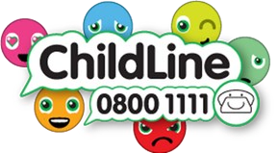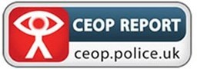



# Child Friendly

**Safeguarding Policy June 2024**

We want City of Rochester school to be a safe place. All the adults at the school will do everything they can to make sure that you are healthy, safe and happy. In our school we respect you, we listen to you, and we help you protect your rights. We do our best to help you make good educational progress.

We teach you how to recognise the risks in different situations and how to protect yourself and stay safe.

**Safeguarding means that school staff should:**

* Protect you from harm.
* Make sure nothing stops you from being healthy or developing properly.
* Make sure you are safely looked after.
* Make sure you have the best life chances and can grow up happy and successful.

**How will staff try to protect you?**

* We will always try to provide a safe and secure environment for you to learn and progress.
* We help to make sure that you remain safe at home, as well as at school.
* We think it is important for you to know where to get help if you are worried or unhappy about something.

**Abuse**

When someone hurts you, it can be called abuse. This is when someone does something to you that is harmful, unpleasant, or painful like:

* If someone deliberately hits you, hurts you, injures you or humiliates you in different ways.
* If someone says or does something that makes you feel bad about yourself or hurts your feelings which makes you feel scared, sad, upset, or frightened.
* If someone shouts, threatens, hits, or hurts someone you love whilst you are around which makes you scared, unhappy, or worried.
* If someone doesn’t take proper care of you so you feel abandoned, lonely, or neglected. You might not be able to eat or wash regularly, or you might not be able to come to school every day or on time.
* If someone touches you in a way that you don’t like for example touching your private parts.
* If someone makes you look at things which make you feel ashamed, embarrassed, uncomfortable, or guilty. They may ask you to keep it a secret or give you presents.

***Abuse is never ok and if you are being or have been abused you must remember – it is not your fault. You must always tell someone, and they will help it to stop.***

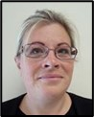**Need to talk?**

Our Designated Lead for Safeguarding is **Kelly Lovell** - this means that Kelly has the main responsibility for making sure you are healthy, safe, and happy.

If you need to talk - we will listen. You can talk to any adult within the school, but there are some staff who help Kelly to make sure you are safe and well cared for.

People in school who can help you include **peer mentors** and:

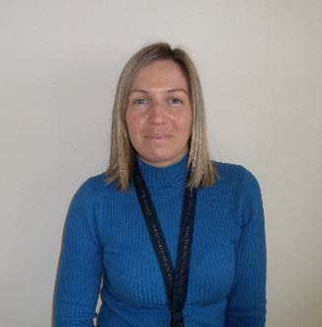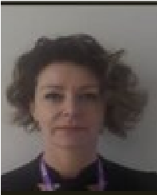

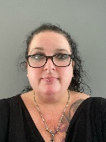**Kaylee Ben-Hania**

**Becci Dunn**

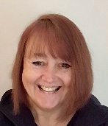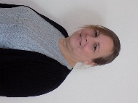**Alicja Emmett**

**Kirstine Boone**

**Alison Barton**

If you do not want to talk, you can always write it down and hand it to a member of staff or press the “Stop Bullying” button on the website or SharePoint.

**What happens next?**

* Sometimes a member of staff at school will need to check things with Kelly and then, if they can deal with the issues themselves, they will.
* There are times though when they may need to contact other agencies for support. These may be Children's Social Care (Social Workers) or Police. There are lots of other agencies who support children and families as well.
* Staff will talk to you and explain all of this, and you can always go and ask staff questions if you are unsure about anything.